**Environment** **Setup**

**Docker** **Account** **Creation**

|  |  |
| --- | --- |
| Team ID | PNT2022TMID50454 |
| Project Name | Nutrition Assistant Application |

**Pooja P**

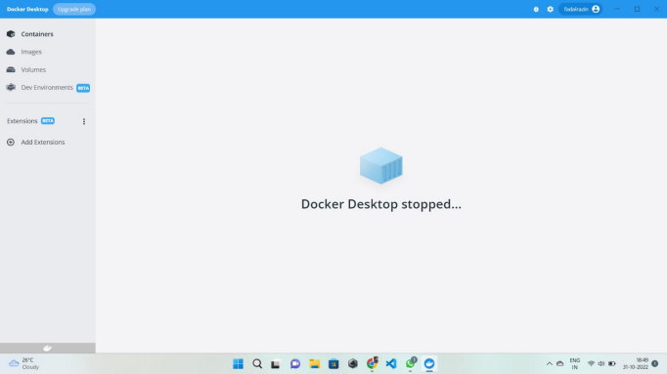

**Thilagavathi N**

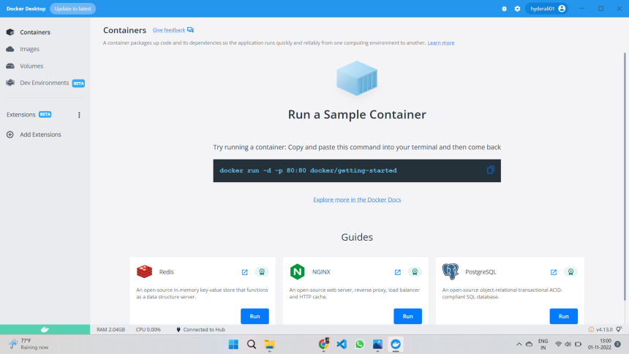

**Sivatharani N**

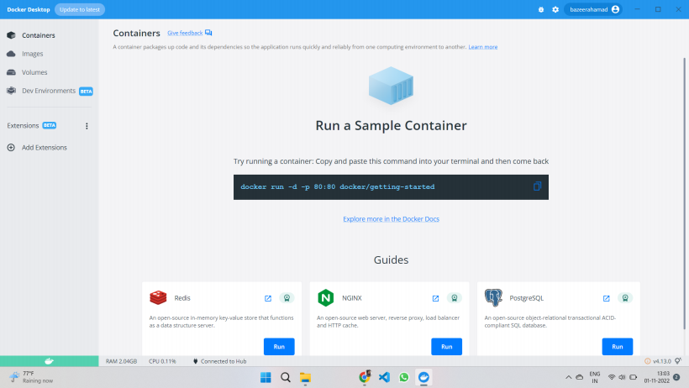

**Maharaja T**

